NORTHWIND SALES DASHBOARD
Using Microsoft Power BI
Project Report
Submitted By
Name: Shibani Sri. U
Tool Used: Microsoft Power BI Desktop
INTRODUCTION:
For this project, I created an interactive Northwind Sales Dashboard using Microsoft Power BI. The dashboard is designed to analyse orders, sales, quantity sold, freight, customer details, employee-wise orders, monthly order patterns, and category-wise sales using the Northwind dataset. The dataset contains details about customers, products, categories, employees, orders, regions, quantities, sales, and freight. These details help in studying different aspects of the organisation's sales and order performance. The main objective of the dashboard is to transform raw sales and order information into a clear and interactive visual report. Instead of manually examining a large amount of data, users can use KPI cards, charts, and filters to understand important information quickly. The dashboard provides information about total orders, total quantity sold, total freight, average freight, number of customers, monthly orders, employee-wise orders, and category-wise sales.
OBJECTIVES:
The major objectives of developing this dashboard are:
- To examine the overall sales and order performance of the business.
- To calculate and display key indicators such as total orders and total quantity sold.
- To study the order pattern across different months.
- To compare the number of orders handled by various employees.
- To analyse sales generated by different product categories.
- To understand the freight associated with the orders.
- To identify the number of customers represented in the data.
- To provide interactive filters for analysing the dashboard.
- To display sales and order information in a simple and understandable manner.
- To understand the application of Power BI in business analysis and decision-making.
DATASET DESCRIPTION:
The project is developed using the Northwind dataset. The dataset contains information about customers, orders, employees, products, categories, regions, quantities, sales, and freight.
Major Fields Used in the Dashboard
The dataset contains sufficient information to examine order, sales, customer, employee, product, and freight performance from different business perspectives.

Field | Description
Order ID | Unique identification number assigned to each order
Customer ID | Identification of the customer related to the order
Employee Name | Employee responsible for or associated with the order
Product Name | Name of the product ordered
Category Name | Product category to which the item belongs
Region | Geographical region connected with the order
Order Date | Date on which the order was placed
Month Name | Month in which the order was placed
Quantity | Number of products included in the order
Sales | Sales value generated from the order
Freight | Freight cost related to the order

DATA PREPARATION:
Before developing the dashboard, the Northwind dataset was prepared using Microsoft Power BI Desktop.
The following data preparation steps were carried out:
- Imported the Northwind dataset into Power BI.
- Reviewed the available columns and their respective data types.
- Checked the Order ID and Customer ID fields.
- Verified the Employee Name field for employee-level analysis.
- Checked Category Name for category-based analysis.
- Verified the Region field for geographical filtering.
- Examined Order Date and Month Name for monthly analysis.
- Checked numerical fields such as Quantity, Sales, and Freight.
- Confirmed that the dataset was appropriate for creating charts and KPI cards.
- Created the required measures for analysing orders and sales-related information.
After the data preparation was completed, the necessary visuals and interactive dashboard elements were developed.
DAX MEASURES USED:
DAX measures were created in Power BI to calculate the main order, sales, freight, and customer indicators.
1. Total Orders:
This measure calculates the total number of orders available in the selected data.
Purpose:
It gives an overall understanding of the number of orders received by the business.
2. Total Quantity Sold:
This measure calculates the total quantity of products ordered.
Purpose:
It helps determine the overall volume of products sold during the selected period.
3. Total Freight:
This measure calculates the complete freight amount associated with the orders.
Purpose:
It helps analyse the total freight cost related to the orders.
4. Average Freight:
This measure calculates the average freight value for the orders.
Purpose:
It helps understand the average freight cost associated with each order.
5. Number of Customers:
This measure calculates the number of customers included in the selected data.
Purpose:
It provides an overview of the customer base represented by the orders.
DASHBOARD COMPONENTS:
The dashboard contains several visual elements, with each visual presenting a different aspect of the business data.
1. TOTAL ORDERS BY MONTH
A line chart is used to represent the total number of orders across the different months.
The chart presents the order pattern from January to December.
For the selected year 2014, the visual shows how the number of orders changes throughout the year. The order activity increases towards the later part of the year, with December showing a noticeable rise.
This chart helps users identify months with comparatively higher or lower order activity.
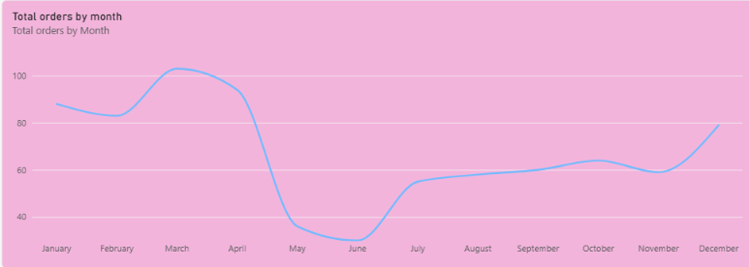
2. TOTAL ORDERS BY EMPLOYEE NAME
A horizontal bar chart is used to compare the number of orders associated with different employees.
The dashboard displays employees such as:
- Margaret Peacock
- Janet Leverling
- Nancy Davolio
- Laura Callahan
- Robert King
- Michael Suyama
- Anne Dodsworth
- Steven Buchanan
The chart provides a comparison of the orders handled by each employee.
It gives a simple view of employee-wise order performance and allows users to understand differences in order activity among employees.
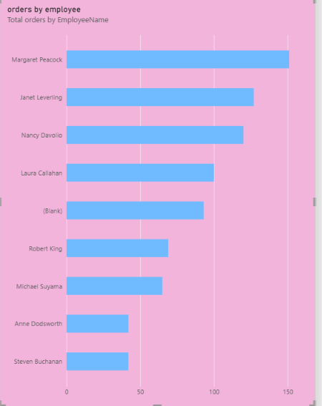
3. TOTAL SALES BY CATEGORY NAME
A column chart is used to show the total sales generated by different product categories.
The categories included in the dashboard are:
- Dairy Products
- Beverages
- Confections
- Meat & Poultry
- Seafood
- Grains & Cereals
- Condiments
- Produce
The column chart makes it easier to compare the sales contribution of the different categories.
Based on the dashboard, Dairy Products records the highest sales among the categories displayed, while Produce and Condiments show comparatively lower sales.
This visual helps in understanding how different product categories contribute to the overall sales.
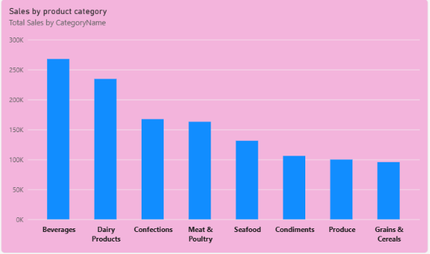

KPI CARDS:
The right section of the dashboard contains KPI cards that provide a quick summary of the main business indicators.
For the selected year 2014, the dashboard displays:
- Total Orders – 408
- Total Quantity Sold – 25K
- Total Freight – 32.47K
- Average Freight – 79.58
- Number of Customers – 91
These KPI cards provide an immediate overview of order volume, quantity sold, freight information, and the number of customers without requiring users to examine each chart separately.
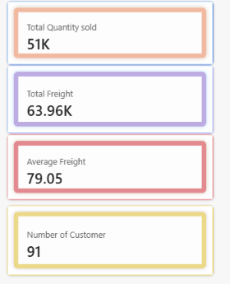
YEAR FILTER:
A Year slicer is provided to filter the dashboard according to the selected year.
The available years are:
- 2013
- 2014
- 2015
Currently, 2014 is selected in the dashboard.
The Year filter allows users to examine order and sales performance for a particular year.
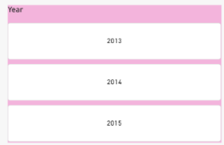

REGION FILTER:
A Region slicer is included to analyse the dashboard based on geographical region.
Users can select an individual region or select All to view the complete dataset.
This filter helps users examine order and sales information based on different regions.

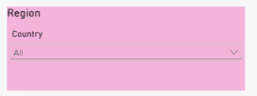

CATEGORY NAME FILTER:
A Category Name slicer is used to filter the dashboard according to product category.
Users can select an individual category or choose All categories.
This filter allows users to study the orders and sales related to a particular product category.

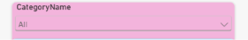

INTERACTIVITY OF THE DASHBOARD:
A major feature of Power BI is the interactive nature of its dashboards.
When users select an option from the Year, Region, or Category Name slicers, the related charts and KPI values are automatically adjusted according to the selection.
For example:
- Selecting a particular year displays the order and sales information for that year.
- Selecting a region allows users to examine information related to that geographical area.
- Selecting a category allows users to study sales and order information for the selected product category.
This interactivity makes the dashboard more useful than a static report because users can explore the information based on their specific requirements.
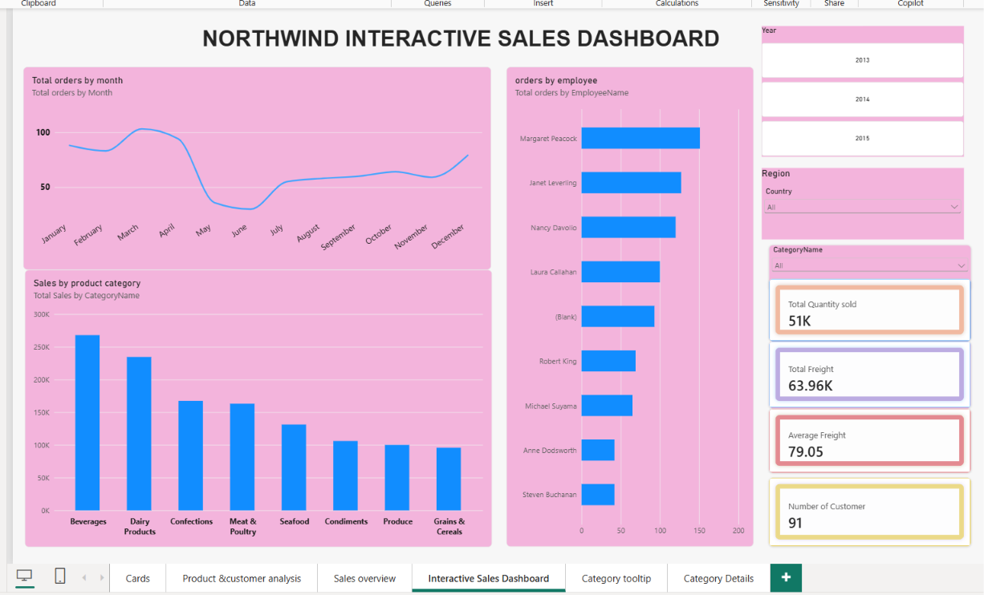

KEY FINDINGS:
The major observations obtained from the dashboard are:
- The selected year in the dashboard is 2014.
- The dashboard displays 408 total orders for the selected view.
- The total quantity sold is approximately 25K.
- The total freight amount is approximately 32.47K.
- The average freight value is 79.58.
- The dashboard represents 91 customers.
- The number of orders changes across the different months of the year.
- A noticeable increase in order activity can be seen towards December.
- Margaret Peacock has the highest number of orders among the employees displayed.
- Sales amounts differ across the various product categories.
- Dairy Products records the highest sales among the categories shown.
- The dashboard includes categories such as Dairy Products, Beverages, Confections, Meat & Poultry, Seafood, Grains & Cereals, Condiments, and Produce.
- The Year, Region, and Category Name slicers allow users to interact with and filter the dashboard.
- The combination of KPI cards and charts provides both a quick overview and a detailed understanding of the business data.
CONCLUSION:
This project helped me gain an understanding of how Microsoft Power BI can be used to analyse and visualise sales and order information effectively. Using the Northwind dataset, I developed an interactive dashboard containing KPI cards, monthly order analysis, employee-wise order comparison, category-wise sales analysis, along with freight and customer information. The KPI cards provide a quick view of total orders, quantity sold, total freight, average freight, and number of customers. The different charts provide additional details about monthly orders, employee performance, and category-wise sales. The Year, Region, and Category Name slicers make the dashboard interactive and allow users to analyse the data based on their selected requirements. Overall, this project enhanced my understanding of Power BI, DAX measures, data visualisation, interactive dashboards, and business data analysis. It also helped me learn how raw sales and order data can be converted into meaningful information for better understanding of business performance.

